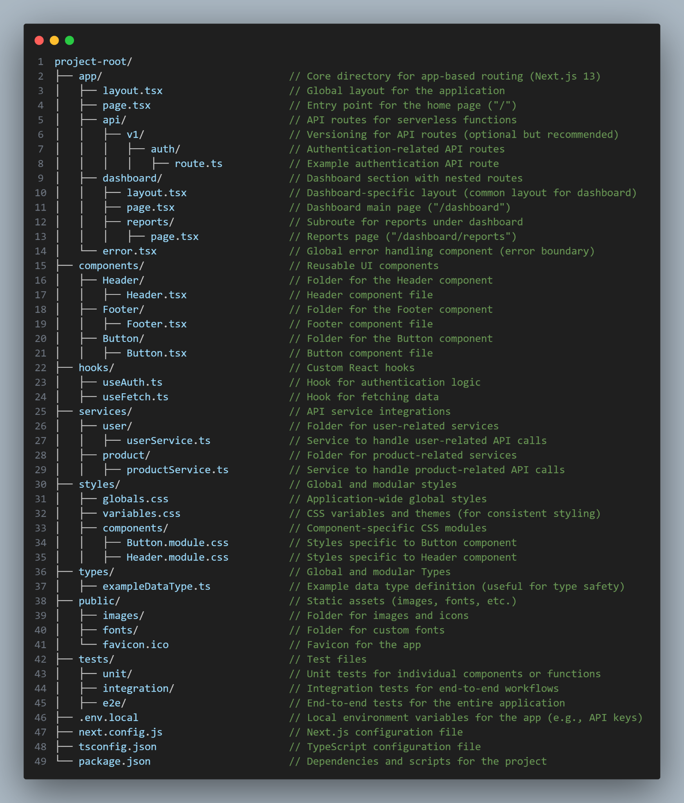

project-root/

├── app/ // Core directory for app-based routing (Next.js 13)

│ ├── layout.tsx // Global layout for the application

│ ├── page.tsx // Entry point for the home page ("/")

│ ├── api/ // API routes for serverless functions

│ │ ├── v1/ // Versioning for API routes (optional but recommended)

│ │ │ ├── auth/ // Authentication-related API routes

│ │ │ │ ├── route.ts // Example authentication API route

│ ├── dashboard/ // Dashboard section with nested routes

│ │ ├── layout.tsx // Dashboard-specific layout (common layout for dashboard)

│ │ ├── page.tsx // Dashboard main page ("/dashboard")

│ │ ├── reports/ // Subroute for reports under dashboard

│ │ │ ├── page.tsx // Reports page ("/dashboard/reports")

│ └── error.tsx // Global error handling component (error boundary)

├── components/ // Reusable UI components

│ ├── Header/ // Folder for the Header component

│ │ ├── Header.tsx // Header component file

│ ├── Footer/ // Folder for the Footer component

│ │ ├── Footer.tsx // Footer component file

│ ├── Button/ // Folder for the Button component

│ │ ├── Button.tsx // Button component file

├── hooks/ // Custom React hooks

│ ├── useAuth.ts // Hook for authentication logic

│ ├── useFetch.ts // Hook for fetching data

├── services/ // API service integrations

│ ├── user/ // Folder for user-related services

│ │ ├── userService.ts // Service to handle user-related API calls

│ ├── product/ // Folder for product-related services

│ │ ├── productService.ts // Service to handle product-related API calls

├── styles/ // Global and modular styles

│ ├── globals.css // Application-wide global styles

│ ├── variables.css // CSS variables and themes (for consistent styling)

│ ├── components/ // Component-specific CSS modules

│ │ ├── Button.module.css // Styles specific to Button component

│ │ ├── Header.module.css // Styles specific to Header component

├── types/ // Global and modular Types

│ ├── exampleDataType.ts // Example data type definition (useful for type safety)

├── public/ // Static assets (images, fonts, etc.)

│ ├── images/ // Folder for images and icons

│ ├── fonts/ // Folder for custom fonts

│ └── favicon.ico // Favicon for the app

├── tests/ // Test files

│ ├── unit/ // Unit tests for individual components or functions

│ ├── integration/ // Integration tests for end-to-end workflows

│ ├── e2e/ // End-to-end tests for the entire application

├── .env.local // Local environment variables for the app (e.g., API keys)

├── next.config.js // Next.js configuration file

├── tsconfig.json // TypeScript configuration file

└── package.json // Dependencies and scripts for the project